Hands On Experience With Git Commands:

A folder git_learning is created under L100_Git directory:

Commands:

1) git init: initialize a new Git repository, A hidden .git folder is created in project directory, allowing Git to start tracking changes, manage versions, and enable collaboration.

Options:
->git init : initializes a Git repository in the current directory
->git init my-project : initializes a repository in a new subdirectory named my-project

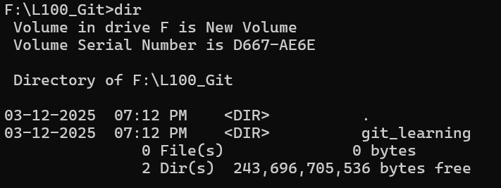

A new fille file.txt is created inside the git_learning folder.

2)git status: Compares the current working directory and index and also compares index with Head pointer
It shows what's untracked, modified, staged, etc.

Options:
-> git status: standard format
-> git status -s: short format

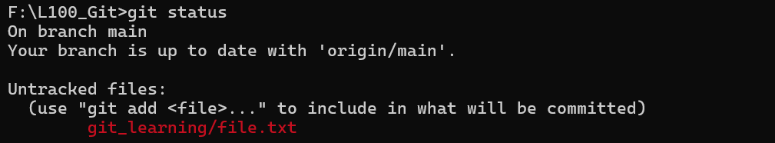

3)git diff :

Options:
->git dif - compares Working Directory vs. Index. (What have I changed but not staged?)
->git diff --cached
->git diff HEAD

A sample file file.txt is been created inside the folder

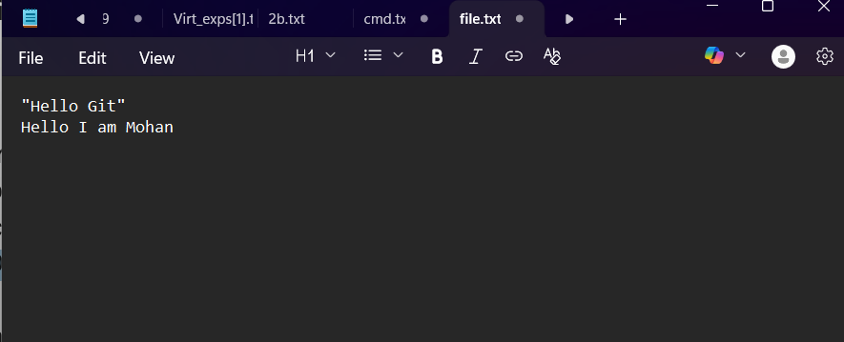

And then the changes are committed
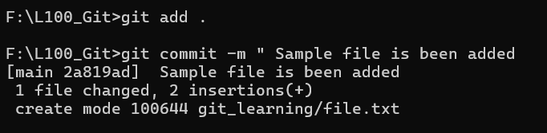

Step 1: Modify the file now and check its status
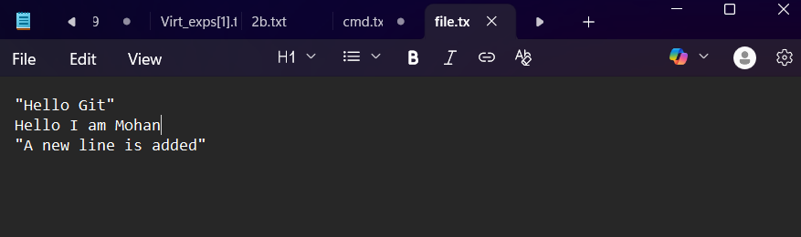

git status will shows the modified file.
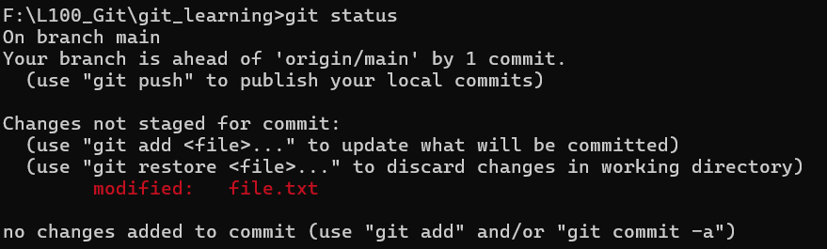

git diff - this command show what content has not been moved to staging area

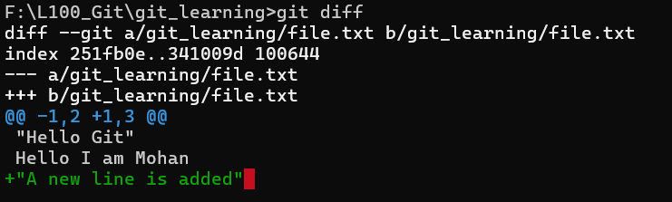

Now the file is being added to the staging:

git diff –cached : This command will tells that the change of content or the file which has been committed and it is ready to commit
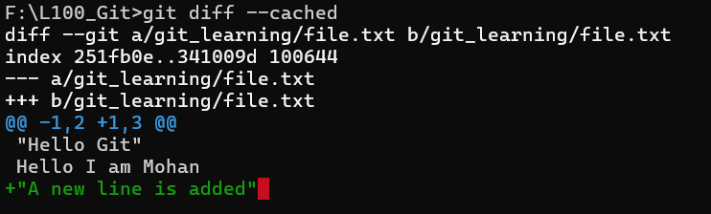
The same git diff command will not display anything as all have been moved from working directiey to staging area


A new line is been added to the file.txt

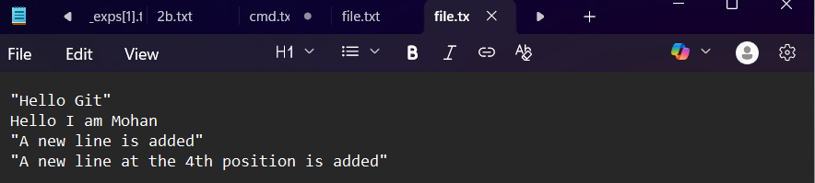

git diff HEAD: This command will compares the Head with the working directory so only all the new staged and staged changes are appearing as a result for this command
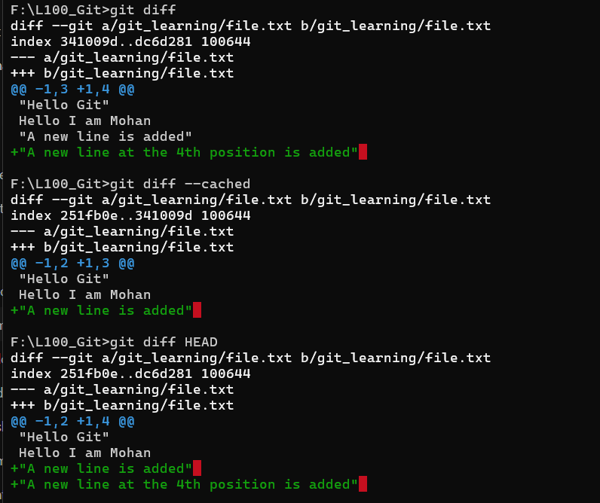

git diff filename

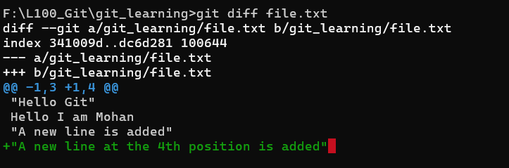

git diff –stat summary format
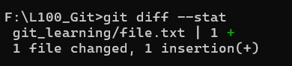

4)git blame :

Options :
-> git blame <filename>
-> git blame -L 10,20 <filename>

git blame <filename>:

This command shows at which commit the specific file content is how changed
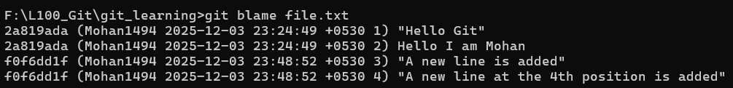

git blame -L 1,3 <filename>

This command show the changes of content between the specific lines

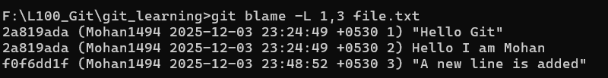

git blame -w file.txt

This command check whether only white spaces have been changed in the file content then those changes will not reflected in the result of this command.

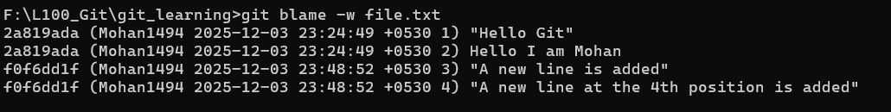

4)git log

Options:
->git log
->git log --oneline
->git log --oneline --graph --decorate --all
->git log -p
-> git log --oneline demo.txt

git log

This commands tells about the entire commit history in detail
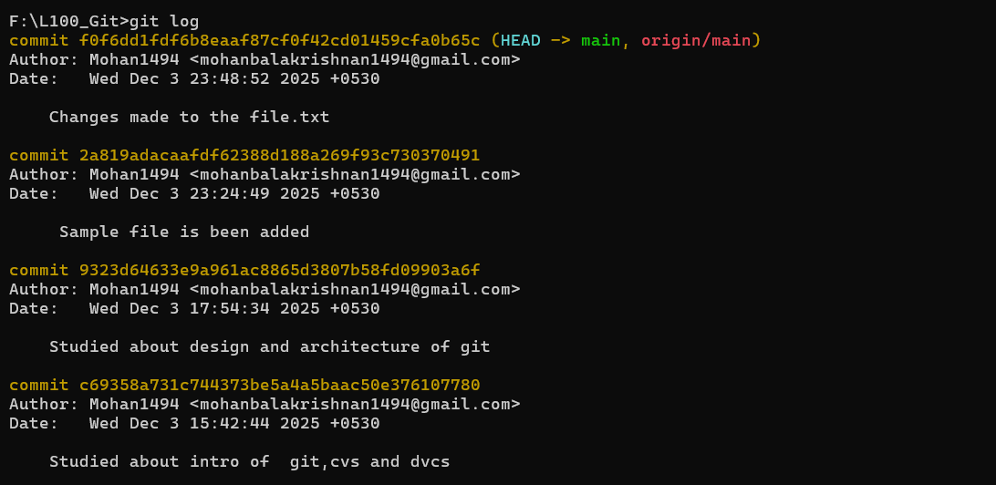

git log --oneline

This command give the history of commits in a single line
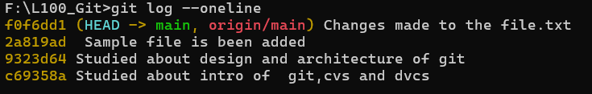

git log --oneline --graph --decorate --all

This command tells about the branching history visually

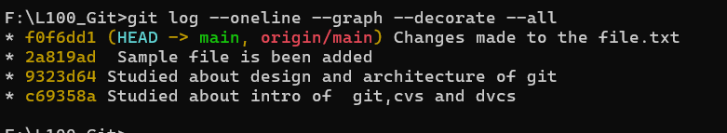

git log -p

This command shows exactly what changed in each commit.

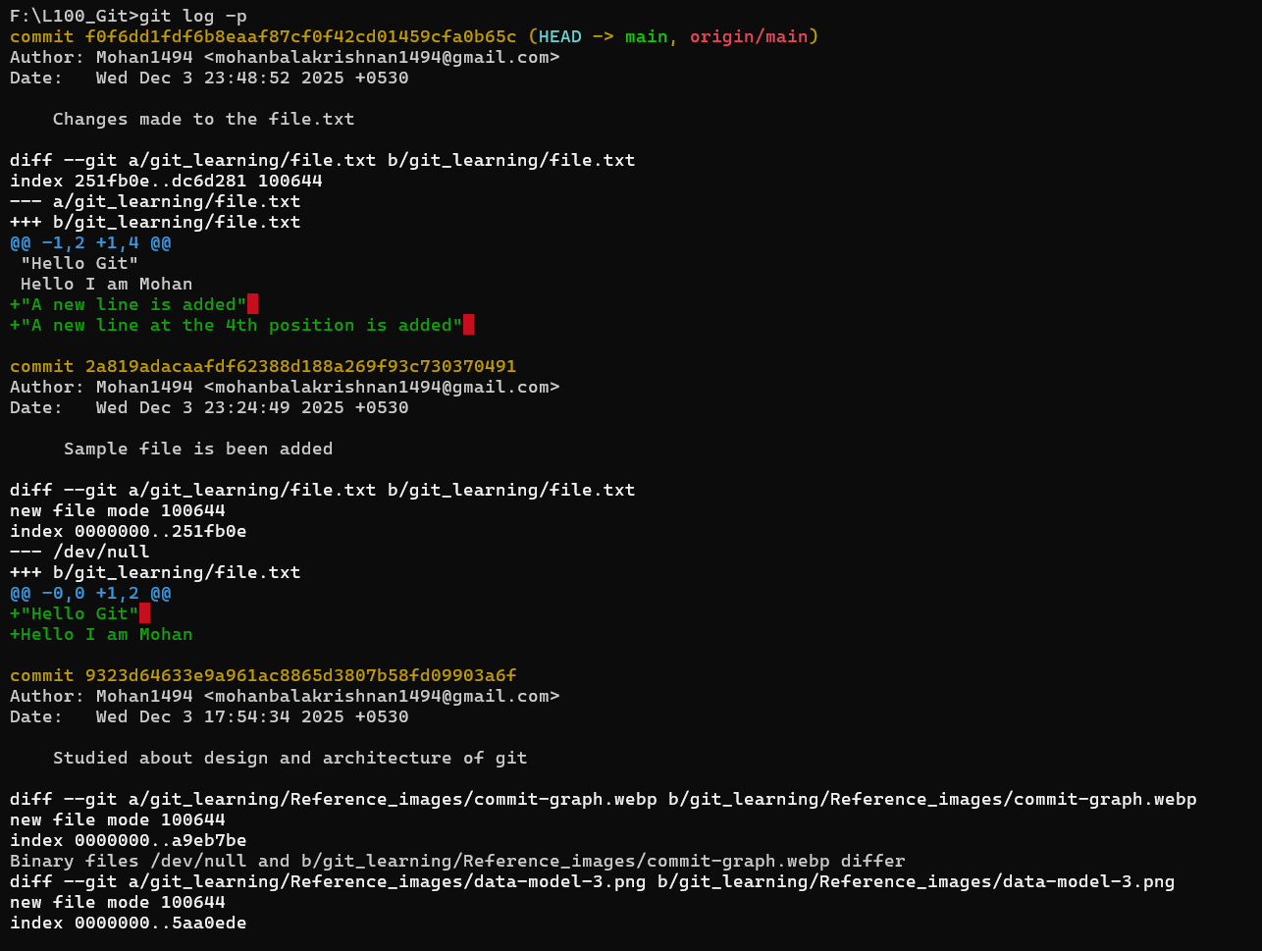

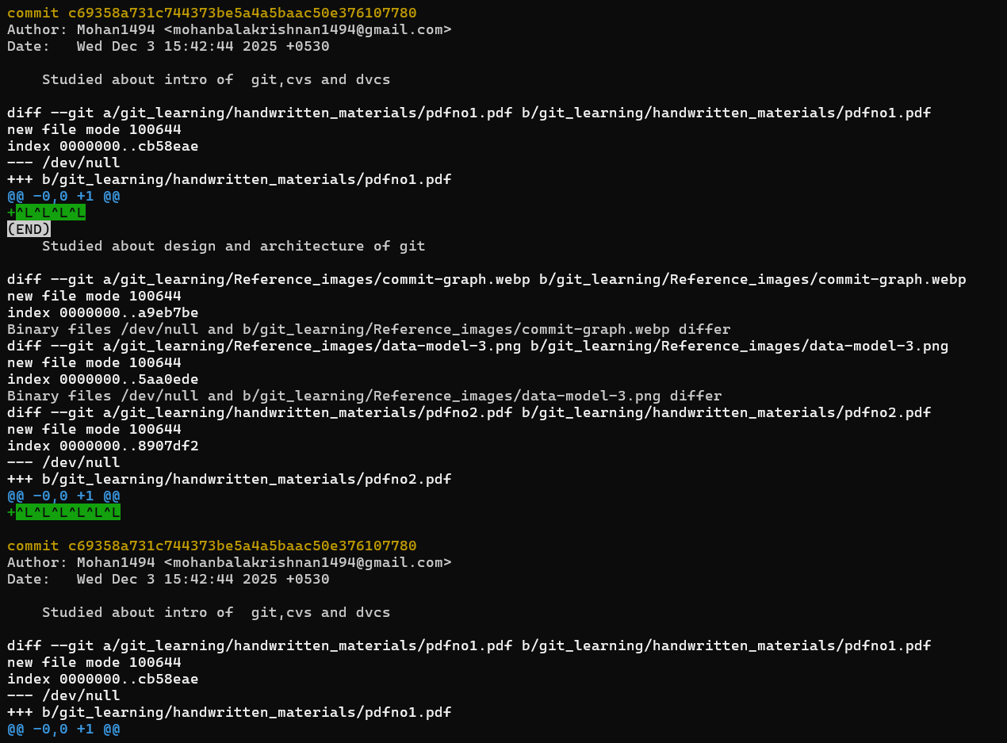

git log --oneline file.txt

This command shows history affecting that file.

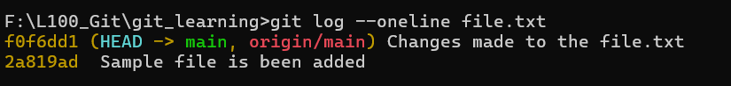

6)git branch

Options:
-> git branch <name>
->git checkout branch (or) git switch branch
->git checkout -b <name>

A new file app.txt is being added to the directory.and changes are maded to that and being staged and committed in the main branch

Then a new branch is created

git branch login-feature

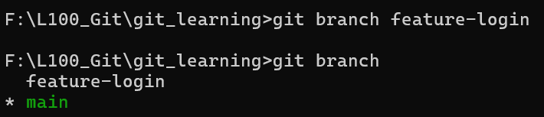

git switch login-feature

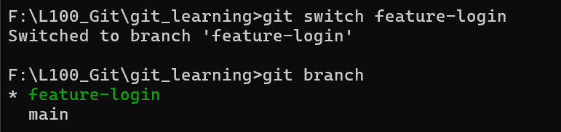

Now the head pointer is being switched to new branch

Changes are made to the file app.txt and it is being staged and committed in login-feature branch
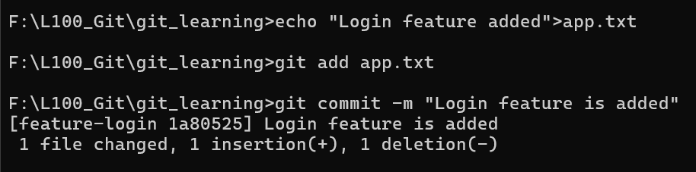

Now switching to main branch
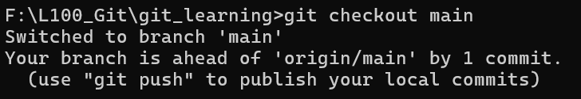

7)git merge

Options:
-> git merge branch
-> git merge –squash

git merge branch
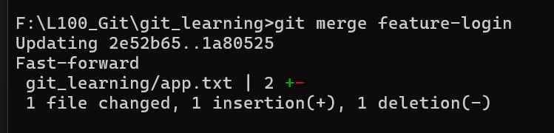

What does the command git merge branch do :
-> First git finds the common ancestor of both the branches
->Next Git creates two diffs
-> Diff means what is being changed in that branch since the common ancestor
->Common ancestor —-> branch1
->Common ancestor —--->branch2
At last two list of changes is created by the git

->Git tries to combine both the lists of changes:
-> if there is no conflict i.e both the branches has changed diff lines
->Then Git combines both the branches automatically
->If conflicts arises there i.e both the branches has changed the same line
->Then Git asks us to fix the conflict manually
->Then Git creates a merge commit

8)git add
-> Compress the file and stores it inside .git/objects
->Updates the Index(Staging Area)
->this version of file will go into commit
Options:
->git add .
-> git add file.txt
->git add -p :Choosing specific lines to stage
9)git reset
Options:
->git reset –soft HEAD~1
->Moves head only but the changes and working files are being kept
->git reset –hard origin/main
->Moves HEAD, resets Index, and resets Working Directory

10)git fetch

First a new file is added to repo by directly in the website
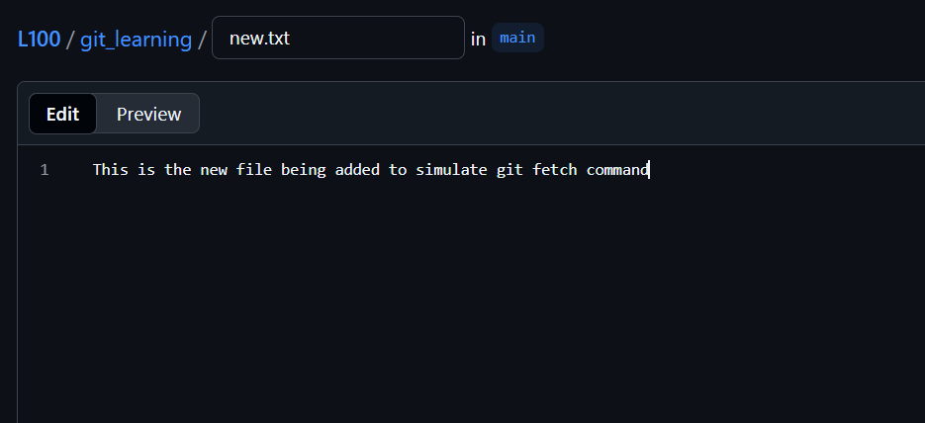
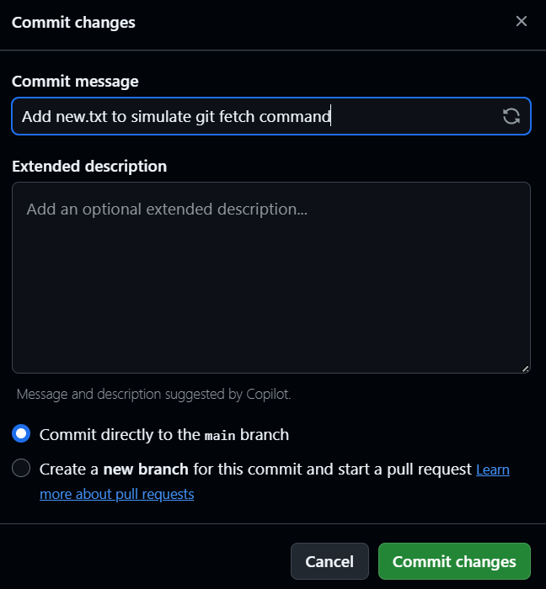

Now GitHub is ahead of our local repo

Now git fetch origin command is being run this downloads the new commits
It just updates the origin/main
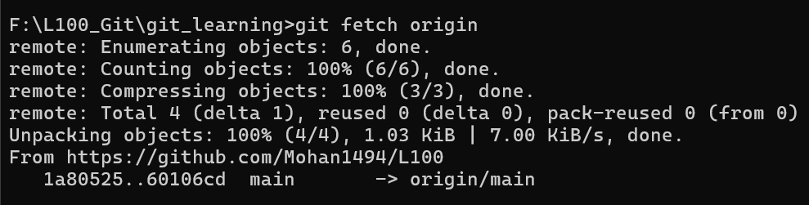

When git status command is running it shows that one commit that github has but our local repo doesnt have
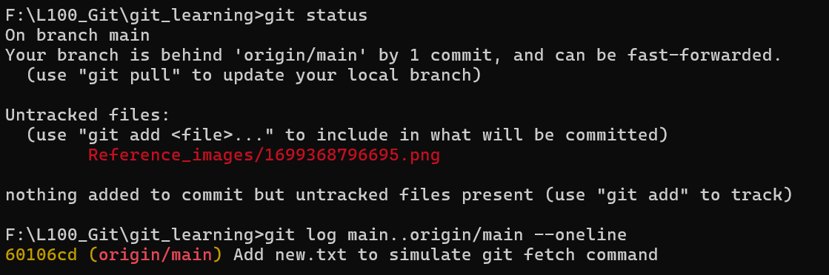
git fetch –prune :This branch deletes the branch reference in the local repo which are already been deleted in the remote
To merge it to our local repo git pull command is used
11)git pull = git fetch + git merge.
This created merge commits
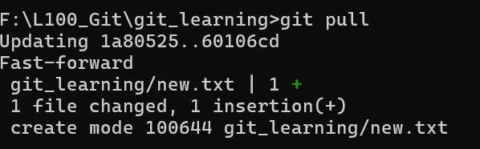
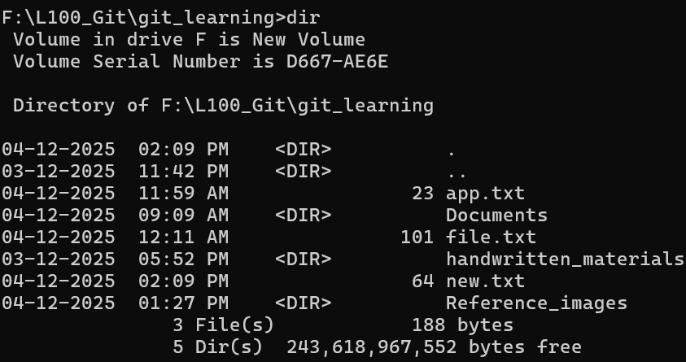

That new file in github repo is being saved to our local repo also.
git pull –rebase = fetch+rebase
This means Yours commits get rebuilt on top of latest remote commits:
Changes and commits are happened to both remote and local repo also4
When that rebase command runs The following flow happens:
- Git downloads GitHub changes
- Git temporarily removes your commit
- Git applies GitHub's commit
- Git re-applies your commit on top
It does not merge commit
10)git push
This command pushes the missing commits(changes to the remote server - Github
git push origin main:Uploads my local main branch commit to the remote repo called origin

Other Commands

11) git mv <old> <new>
12) git rm <file>:Delete that file
13) git reset<file>:Unstage one file
14) git reset : Unstage everything
15)git commit -am ‘message’ : Commit all unstaged changes
- git add <all tracked files>
- git commit -m "message"
Discarding changes:
16)git restore <file> only unstaged
17)git restore --staged --worktree <file> : both unstaged and staged
18)git clean - Delete untracked files

